Name: ___________________________________
Summer Phone Number: ___________________________
ID Number: ___________________ 8th grade counselor: Carli.Page@hcps.org
Listed below are courses available for 9TH GRADE STUDENTS. No classes are guaranteed.

Graduation requirements and course descriptions can be found in the HCPS Student Educational Planning Guide: http://www.hcps.org/sepg
Your high school counselor will be based on your last name:
A to Di Bob.Winter@hcps.org Ko to Ri Kristi.Palmerino@hcps.org
Do to Kn Jennifer.Behler@hcps.org Ro to Z Mark.Szot@hcps.org

This sheet is to be completed and returned to your teacher by February 20th.
I understand that every effort will be made to build my schedule with the courses listed below. If choices are not available, my backup course selections may be substituted. List two backup courses:

Parent/guardian signature: _________________________________________ Date: _______________________________________

Each student will take eight credits, Health/Physical Education (1 credit total) has been selected for you with an X, you will need seven more X’s for a total of 8.
  ENGLISH
  You must choose one.
  ☐ | EN0101 |  | English I
  ☐ | EN01W61 |  | Honors English I (W)
  SCIENCE
  You must choose one.
  ☐ | SC0201 |  | Biology
  ☐ | SC02W61 |  | Honors Biology (W)
  SOCIAL STUDIES
  You must choose one.
  ☐ | SS0501 |  | US History
  ☐ | SS0671 |  | AP US History (W)
  HEALTH/PHYSICAL EDUCATION every 9th grade student must take
  X | BKHPE9 | Health (SEM) and Physical Education (SEM)
  MATHEMATICS
  You must choose a math class based on the class you are in this year.
  ☐ | BKALGA  (Counts as 2 x marks) |  |  | Intro to Alg. and Alg. I (both must be  taken) = 2 credits (D)
  ☐ | MA0201 |  |  | Algebra I
  ☐ | MA0401 |  |  | Geometry
  ☐ | MA0701 |  |  | Algebra II
  ☐ | MA07W61 |  |  | Honors Algebra II (W)
  FINE ART
  Must choose one, can take more
  ☐ | AR0201 |  | Fine Art Preparation
  ☐ | DR1201 |  | Drama I
  ☐ | MU0101 |  | Chorus I
  ☐ | MU2901 |  | Orchestra
  ☐ | MU2201 |  | Symphonic Band
  ☐ | MU1301 |  | Guitar Lab (LS)
  WORLD LANGUAGE- if you have room
  ☐ | FL0101 | French I
  ☐ | FL0201 | French II
  ☐ | FL0701 | Spanish I
  ☐ | FL0801 | Spanish II
  ☐ | FL1301 | German I
  ☐ | FL1401 | German II
  Completer Classes- can choose
  ☐ | BE1601 | Principles of Business Management and Entrepreneurship
  ☐ | CA0501 | Principles of Art, Media, and Communication
  ☐ | CT0401 | Agriculture I
  ☐ | FC0101 | Introduction to Food Prep
  ☐ | CA6001 | Child Growth & Development
  ELECTIVES – if you have room
  ☐ | BE0301 | Financial Literacy & Tech.
  ☐ | CT81W01 | GIS 1 = 1 credit (must be taking Geom. or Alg. II next year) (W)
  ☐ | EN0701 | Journalism
  ☐ | EN1531 | Creative Writing (LS)
  Science Electives- You must be taking Honors Biology and Algebra II in grade 9 to be eligible.
  ☐ | BKZOMA | Zoology/ Marine Science
  ☐ | SC1071 | AP Environmental Sci W
  Total x’s, add all three columns together, be sure they equal 8 when added together

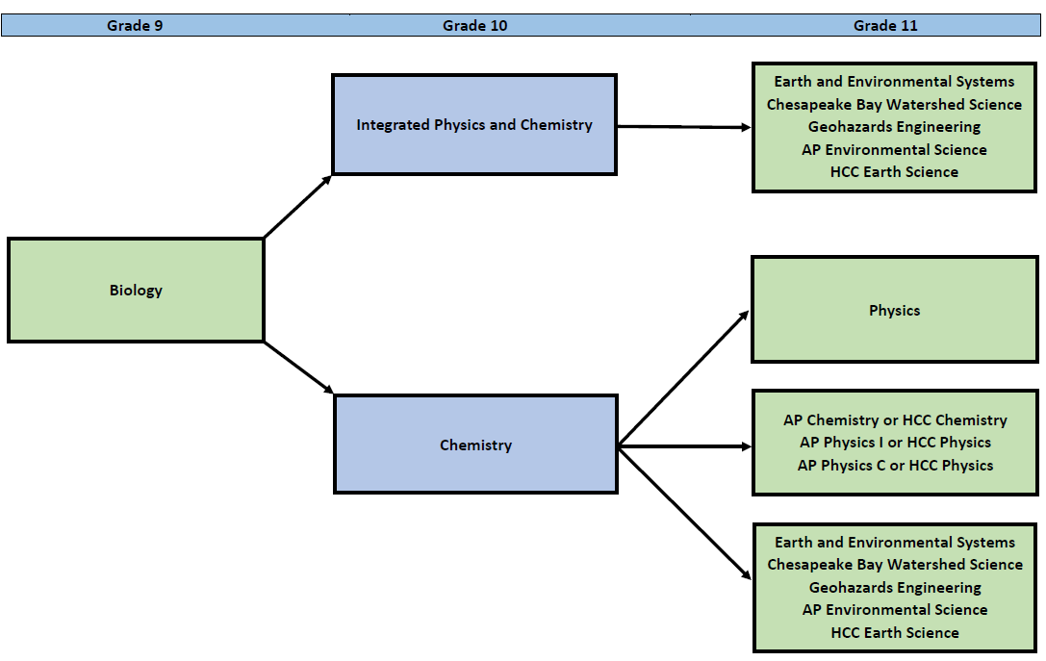

Math Sequence
